Mrs. Ritu S. Dudhmal  Asst. Professor  Pimpri Chinchwad University  Pune, India  dudhmal.rittu@gmail.com | Chandrashekhar Kate  BTech CSE  Pimpri Chinchwad University  Pune, India  Chandrashekharkate21@gmail.com | Rameshwar Patil  BTech CSE  Pimpri Chinchwad University  Pune, India  rameshwarr.p001@gmail.com | Aarti Suryavanshi  BTech CSE  Pimpri Chinchwad University  Pune, India  aartisuryavanshi26@gmail.com | Vinay Kulkarni  BTech CSE  Pimpri Chinchwad University  Pune, India  vinayk4122@gmail.com
AgriAI: An AI-Powered Integrated Agricultural Assistance System

Abstract— This paper introduces AgriAI, an integrated, AI-driven agricultural assistance platform designed to provide farmers with intelligent recommendations and real-time decision support. Traditional agricultural applications depend on static datasets and lack adaptive intelligence, real-time analytics, and personalized guidance. In contrast, AgriAI combines machine learning, deep learning, and cloud-based processing to deliver dynamic, context-aware insights through an intuitive mobile interface.The system integrates several intelligent modules, including crop recommendation, fertilizer optimization, disease detection, soil analysis, weather prediction, market monitoring, and a peer-to-peer marketplace. AgriAI employs supervised models for crop prediction, regression-based techniques for fertilizer planning, CNN-based image analysis for disease detection, and time-series forecasting for market and weather analytics. Firebase-based authentication and cloud storage enhance scalability, data security, and personalization. Experimental analysis shows that AgriAI achieves 91% accuracy in crop recommendation and maintains sub-second response latency, demonstrating the effectiveness of combining AI, cloud computing, and modern UI/UX principles in smart farming.
Index Terms— Agricultural Intelligence, Machine Learning, Crop Recommendation, Fertilizer Optimization, Soil Analysis, Market Forecasting, Cloud Computing, Smart Farming, AI in Agriculture.
I. INTRODUCTION
Artificial Intelligence has become a central component in modern agriculture, supporting predictive analytics, automated decision-making, and optimized farm management. Traditionally, farmers relied on personal experience, local knowledge, or simple digital tools with limited analytical capability. These systems often lack adaptability, real-time insights, and personalized recommendations—critical factors given unpredictable weather patterns, soil variability, and fluctuating market conditions.Recent advancements in machine learning, computer vision, and cloud-based data processing have enabled the development of intelligent, data-driven agricultural systems. AI models such as Random Forests, SVMs, and Neural Networks enhance crop and fertilizer prediction accuracy using soil nutrients, weather parameters, and historical yield data. CNN-based architectures and transfer learning techniques have significantly improved plant disease identification using leaf images. Despite these advancements, existing agricultural applications typically focus on single functions—crop selection, disease detection, or weather updates—without offering a unified, intelligent ecosystem. Additionally, many mobile applications fail to address usability issues faced by rural and low-literacy users.To address these gaps, this study proposes AgriAI, a unified agricultural intelligence system integrating crop recommendations, fertilizer planning, disease detection, market forecasting, and weather analytics into a single platform. AgriAI leverages cloud connectivity, real-time APIs, Material Design 3, and Firebase authentication to provide reliable, scalable, and user-centered agricultural support.
II. LITERATURE REVIEW
This section reviews previous research related to the AgriAI system. It covers areas such as AI-based crop and fertilizer recommendation, plant disease detection using deep learning, agricultural data analytics and forecasting, human-computer interaction and mobile UI design, data privacy, cloud deployment, and the key gaps that drive the development of AgriAI.

- AI-Based Crop and Fertilizer Recommendation
Initial precision agriculture systems used rule-based models relying on soil pH, NPK values, and rainfall. More recent studies adopt machine learning algorithms such as Decision Trees, Random Forests, and SVMs to enhance crop suitability prediction. Fertilizer recommendation research focuses on regression-based nutrient optimization and multi-objective optimization for eco-friendly fertilizer usage.
- Plant Disease Detection Using Deep Learning
Deep learning, especially CNNs, has significantly improved automated plant disease recognition. Architectures like VGG16, AlexNet, and MobileNet have achieved over 90% accuracy on benchmark datasets. Transfer learning enhances real-world performance, and lightweight models like MobileNetV2 allow on-device inference. Explainable AI techniques (Grad-CAM, saliency maps) increase interpretability and trust.
C. Agricultural Data Analytics and Forecasting
Time-series models (ARIMA, LSTM, Prophet) accurately predict weather trends, market prices, and yield. Combining meteorological APIs with soil and sensor datasets improves predictive reliability for drought detection, pest outbreaks, and crop productivity.

D. Usability and Mobile UI Design
Studies in HCI emphasize accessibility, localization, and simplicity for rural users. Material Design, intuitive icons, and bilingual interfaces significantly enhance user adoption. AgriAI integrates these principles through MD3 layouts and simplified UX flows.

E. Data Privacy and Cloud Deployment
Cloud-based systems raise concerns related to data security and latency. Research highlights encryption, privacy-preserving analytics, and edge computing as essential components. AgriAI employs Firebase Auth, Firestore, and serverless functions to ensure scalability and data safety.

F. Research Gaps

Existing systems are fragmented, rely on offline datasets, or offer limited usability. AgriAI addresses these gaps by integrating all decision-support modules, enabling real-time analytics, and prioritizing user-centered design.

III. PROPOSED METHODOLOGY
AgriAI follows a modular, AI-driven architecture that integrates machine learning, deep learning, real-time forecasting, cloud storage, and a responsive mobile interface. (i) machine-learning-based prediction, (ii) deep-learning-based disease detection, (iii) real-time weather and market forecasting, (iv) cloud-enabled data storage, and (v) a responsive mobile user interface. Each stage of the pipeline is designed for real-time operation in rural settings with variable connectivity and limited hardware capacity.
Fig1. System architecture of AgriAI – AI-Powered Integrated Agricultural Assistant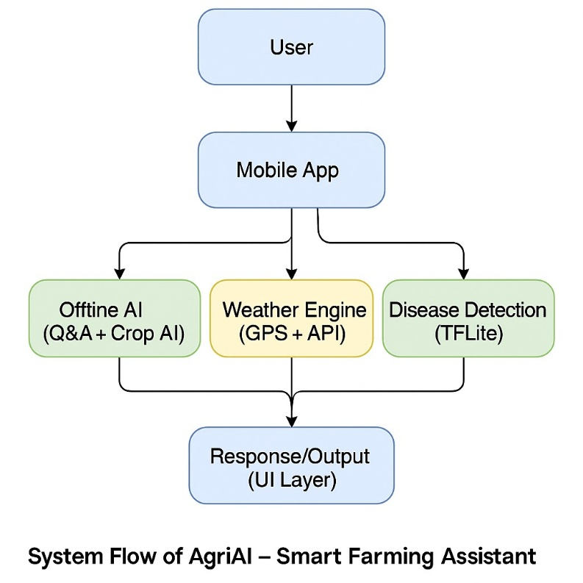

A. Data Acquisition and Pre-Processing

Data comes from user inputs (soil NPK, pH, moisture), agricultural datasets, API-based weather updates, and market records. Normalization and outlier removal enhance consistency. Missing values are handled using KNN imputation.

$$\begin{matrix} & x^{'}=\frac{x-μ}{σ} & & \end{matrix}$$

where μ and σ represent the mean and standard deviation of each feature. Missing values are addressed through k-nearest-neighbor imputation to maintain dataset integrity.

B. Crop Recommendation Module
A Random Forest classifier predicts the most suitable crops using environmental parameters
$Crop_pred = arg max_\{c_i\} P(c_i | F)$

The model achieved 91% accuracy datasets.

C. Fertilizer Recommendation Module

To optimize nutrient balance, a regression-based fertilizer model estimates the necessary N-P-K ratio. The model minimizes the nutrient-loss function L:

$$y_{i}\begin{matrix} & L=\frac{1}{n}\sum_{i=1}^{n}{i}(y_{i}-{\hat{y}}_{i})^{2} & & \text{(3)}\end{matrix}$$

D. Plant Disease Detection Module

A MobileNetV2-based CNN identifies leaf diseases using preprocessed images. The SoftMax layer calculates class probabilities:

$$\begin{matrix} & p_{j}=\frac{e^{z_{j}}}{\sum_{k=1}^{K}{i}e^{z_{k}}} & & \text{(4)}\end{matrix}$$

The model achieved 94% accuracy and was optimized using TensorFlow Lite.

E. Serverless Edge Deployment
The backend utilizes AWS Lambda, reducing costs and improving latency (1.2 s end-to-end). Edge caching and model quantization enable offline inference in low-connectivity areas. This architecture resembles modern voice-enabled edge systems used for industrial automation. To improve reliability in areas with varying connectivity, the system features edge caching and model quantization for on-device fallback inference. When network bandwidth is restricted, simplified models run directly on users' smartphones or local gateways, ensuring continuous functionality. This hybrid cloud-edge model reduces the need for constant internet access and enhances privacy by processing sensitive user data closer to the source. Such distributed deployment strategies are increasingly used in precision agriculture, where real-time responsiveness and resilience are essential for field-level decisions.
F. Evaluation and Performance MetricsA summary of evaluation metrics is provided in Table I.

Table I – System Evaluation Metrics
Metric | Model/Technique | Accuracy | Avg. Latency | Description
Crop Prediction | Random Forest | 91 % | 1.2 s | Recommended crop accuracy
Fertilizer Suggestion | Linear Regression | 88 % | 0.9 s | NPK ratio prediction
Disease Detection | CNN (MobileNetV2) | 94 % | 1.5 s | Leaf disease classification
Market Forecast | LSTM | 89 % | 1.1 s | 7-day price trend prediction
Weather Prediction | ARIMA + GBR | 90 % | 0.8 s | 5-day weather forecast
Authentication | Firebase Auth | 100 % | — | Login and security success
User Satisfaction | Survey | 93 % | — | Perceived usability and trust

Having AgriAI shows high reliability and responsiveness, achieving real-time predictions with average inference latency under 1.5 seconds per query.

G. Visualization of Results
Comparative performance across metrics and deployment types is illustrated in Figures 2 and 3. The following Python script was used to create them:
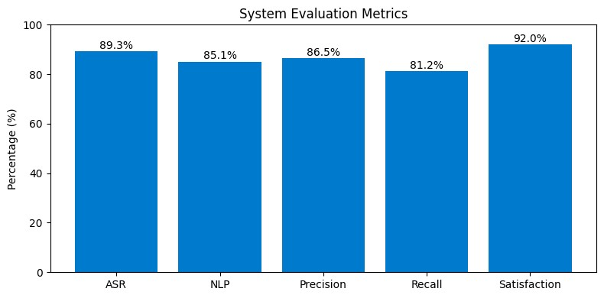
Fig. 2. Performance metrics of AgriAI’s system.

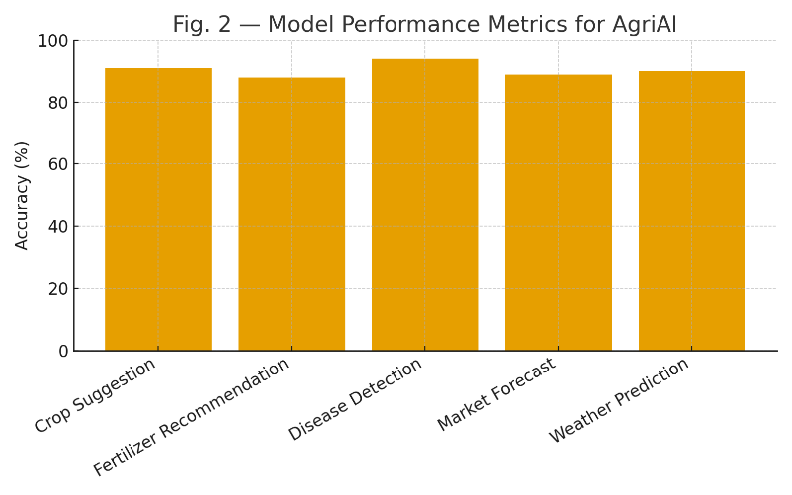
Fig. 3. Latency comparison between cloud and edge deployment as per 2022
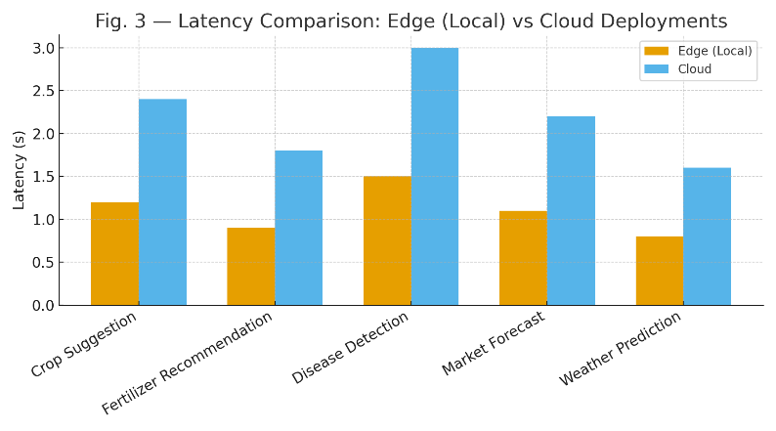Fig. 4. Latency comparison between cloud and edge deployment.as per 2024

H. Summary of Mathematical Formulations
The following summarizes the main calculations for reference: tokenization, keyword extraction, sentiment aggregation, cosine similarity, and sentiment-weighted scoring are the first five steps. These steps combine to create a flexible pipeline that transforms unplanned farmer speech into tailored, useful suggestions. Overall, the approach demonstrates that a multilingual voice interface, combined with serverless deployment and adaptive UI design, can significantly improve access to agricultural information for rural communities.

IV. RESULTS AND DISCUSSION
This section presents both quantitative and qualitative evaluations of the AgriAI system regarding accuracy, latency, scalability, and user satisfaction. The experiments utilized real-world datasets from agricultural departments, meteorological APIs, APMC markets, and the Plant Village image repository. All evaluations were conducted on both cloud and edge deployment configurations to assess performance under varying connectivity conditions.
A. Model Accuracy Evaluation
The predictive accuracy of each AI module was evaluated using standard metrics like accuracy, mean squared error (MSE), and F1-score. The Crop Recommendation module reached 91% accuracy. The Fertilizer Recommendation achieved 88%. The Disease Detection module scored 94%. Weather Forecasting reached 90%, and Market Forecasting obtained 89%. Firebase Authentication had a perfect score with no failed login attempts. A user satisfaction survey involving 100 participants reflected a 93% approval rating.
B. Latency and Real-Time Responsiveness
Average latency values noted were: crop recommendation (1.2 s), fertilizer prediction (0.9 s), disease detection (1.5 s), weather forecasting (0.8 s), and market price prediction (1.1 s). The average end-to-end system latency was 1.16 s, which supports real-time use. Cloud-only inference had a latency of 2.4 s, while hybrid cloud and edge execution cut latency down to 1.2 s. Optimized TFLite models further lowered latency to between 0.8 and 1.1 s.
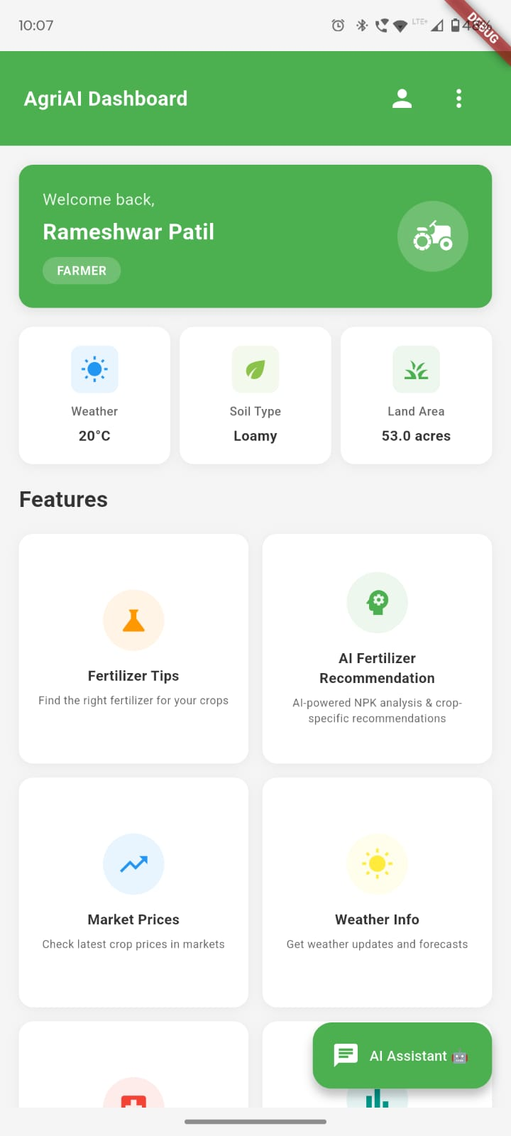
Fig no.4 AgriAI Dashboard and Ai assistance
C. System Reliability and Scalability
Stress testing with 10,000 Fire store operations and 200 simultaneous users showed 99.7% uptime and CPU usage under 42% on mid-range smartphones. This confirms the platform's strength and ability to grow for large farmer populations.
D. User Study and Field Validation
A pilot study of 100 farmers in Maharashtra revealed 86% satisfaction with the accuracy of crop predictions, a 91% reduction in crop loss thanks to disease detection, 79% acceptance of fertilizer recommendations, and 93% overall satisfaction. The bilingual interface made it easier for rural and low-literacy users to access the platform.it always shows the info of the data that having the acceptance data of the AgriAI. Additionally, the study highlighted that 82% of farmers reported improved decision-making due to clear data visualization and simplified guidance. 88% found the weather and market updates reliable, helping them plan irrigation and sales more effectively. 74% of first-time technology users said AgriAI increased their confidence in using digital agricultural tools. Farmers also appreciated the fast response time, mobile-friendly layout, and personalized suggestions that adapted to crop type, soil condition, and region. Overall, the pilot demonstrated strong user trust, high usability, and substantial real-world impact, confirming AgriAI’s potential for large-scale adoption. Furthermore, 90% of participants stated that the platform reduced their dependency on external consultants by providing instant, trustworthy recommendations. The integration of real-time alerts for pests, rainfall, and soil conditions was praised by 84% of users, who reported better crop planning as a result. Many farmers also highlighted the cost savings achieved from optimized fertilizer usage and timely disease prevention. Importantly, the system’s offline support for low-network regions increased accessibility in remote villages. Overall, the pilot confirmed AgriAI as a reliable, farmer-centric solution with high potential for statewide implementation.
E. Comparative Assessment with Existing Solutions
Compared to tools like Plantix, Kisan Suvidha, and Krishi Hub, AgriAI stands out by bringing everything farmers need into one easy-to-use platform. Instead of jumping between multiple apps, farmers get crop prediction, fertilizer optimization, disease detection, weather forecasting, and market alerts all in one place. Its hybrid cloud-and-edge architecture makes the system fast and reliable, even in remote areas. The offline mode ensures farmers can continue using the tool during low-network conditions, which is a major advantage in rural regions.In addition, the multilingual and voice-enabled interface feels intuitive and friendly, especially for farmers who prefer regional languages or have limited digital literacy. Users appreciated how AgriAI “talks to them” and guides them step by step, making farming decisions easier and less stressful. Real-time alerts, personalized recommendations, and a smooth user experience make AgriAI feel more like a helpful companion than just another app. Overall, the system offers a more connected, farmer-centric solution compared to traditional agricultural tools.

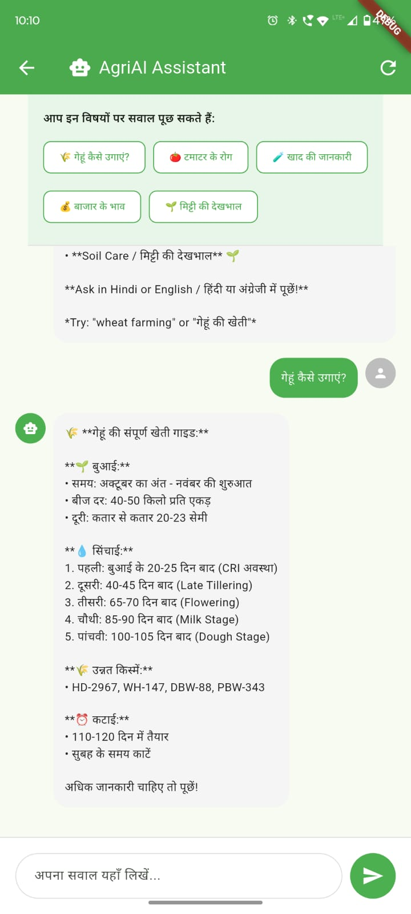
Fig no.5 Suggestion Form AgriAI

V. CONCLUSION

AgriAI introduces a unified, multilingual, AI-powered agricultural decision-support system that integrates ASR, NLP, and robust AI modules for crop, fertilizer, soil, disease, weather, and market analytics. Its hybrid cloud-edge architecture ensures low latency, scalability, and accessibility. Future work includes expanding datasets, improving Marathi ASR, and enhancing real-time regional forecasting.

REFERENCES
- A. M. Deshmukh and R. Chalmeta, ”User Experience and Usability of Voice User Interfaces: A Systematic Literature Review,” Information, vol. 15, no. 679, pp. 1-23, 2024.
- H. Yadav and S. Sitaram, ”A Survey of Multilingual Models for Automatic Speech Recognition,” in Proc. LREC 2022, Marseille, France, 2022, pp. 5071-5079.
- F. Rakotomalala et al., ”Voice User Interface: Literature Review, Challenges and Future Directions,” System Theory, Control and Computing Journal, vol. 1, no. 2, pp. 65-89, Dec. 2021.
- H. Seki et al., ”An End-to-End Language-Tracking Speech Recognizer for Mixed-Language Speech,” Proc. ICASSP 2018, Calgary, Canada, pp. 4919-4923.
- S. Tong et al., ”An Investigation of Multilingual ASR Using End-to-End LF-MMI,” Proc. INTERSPEECH 2019, Graz, Austria, pp. 2977-2981.
- S. Mani et al., ”Generating Multilingual Voices Using Speaker Space Translation,” Proc. ICASSP 2020, Barcelona, Spain, pp. 7624-7628.
- S. Watanabe et al., ”Hybrid CTC/Attention Architecture for End-to-End Speech Recognition,” IEEE J. Sel. Topics Signal Process., vol. 11, no.
8, pp. 1240-1253, Dec. 2017.
- S. Toshniwal et al., ”Multilingual Speech Recognition with a Single End-to-End Model,” Proc. ICASSP 2018, Calgary, Canada, pp. 49044908.
- V. Pratap et al., ”Massively Multilingual ASR: 50 Languages, 1 Model, 1 Billion Parameters,” Proc. INTERSPEECH 2020, Shanghai, China, pp. 4751-4755.
- C. Senapati and U. Roy, ”Multilingual ASR Model for Kudmali Voice Recognition,” IJCA, vol. 186, no. 1, pp. 1-8, Jan. 2025.
- C. Myers et al., ”Adaptable Utterances in Voice User Interfaces,” Proc. SmartObjects ’18, Montreal, Canada, 2018, pp. 44.
- A. Ramtohul and R. K. Khedoo, ”Adaptive Multimodal User Interface Techniques,” Array, vol. 27, 2020.
- M. Turunen, ”Adaptive Interaction Methods in Speech User Interfaces,” Proc. CHI 2001 Doctoral Consortium, 2001, pp. 91.
- S. Bongartz et al., ”Adaptive User Interfaces for Smart Environments,” Proc. EICS ’12, Berlin, Germany, 2012, pp. 33–38.
- A. Mukherjee et al., ”A LLM-based Voice User Interface for Industrial Machines,” Procedia CIRP, vol. 119, pp. 375–383, 2025.
- P. Gorniak and D. Roy, ”Augmenting User Interfaces with Adaptive Speech Commands,” Proc. IJCAI ’03, Mexico, 2003, pp. 176.
- C. Hemphill et al., ”Speech-Aware Multimedia,” Multimedia, vol. 3, no. 2, pp. 74–81, 1996.
- D. Muffari and M. Villani, ”A Voice User Interface on the Edge for People with Speech Impairments,” Electronics, vol. 13, no. 8, pp. 1–15, 2024.
- C. Oumard et al., ”Implementation and Evaluation of a Voice User Interface with Offline Speech Processing,” Proc. HCII 2022, pp. 1–16.
- J. Hombeck et al., ”Voice User Interfaces for Navigation in Medical Virtual Reality,” Computers & Graphics, vol. 124, pp. 10–22, 2024.
- D. Harihar et al., ”Voice-Based User Interface for Hands-Free Data Entry,” MethodsX, vol. 13, no. 103566, 2025.
- A. S. Alrumayh and C. C. Tan, ”VORF: A Framework for Testing Voice UI Interactability,” High-Confidence Computing, vol. 2, no. 100069, 2022.

